Cmp306 unit 1 terminal assessment answers
1903299 Connor Murphy

1a) as the developer of the dealer website wanting to use the manufacturers web service, the main way would be to use an authorised API Key. Using the API method would involve calling a specific web address with the API key and the relevant variables used to find the wanted data. which would look something like this:
APIKey= hsduisfdbui
ItemID = 2
url = manufactures website link + APIKey + Item ID
now this url variable can be used to get the desired information. However, depending on how the manufacture has set up the web service, the two ways to my knowledge are, as a set of functions manipulating a database or a function accessing xml files. Either way the method for getting them are as follows:
functions on a database
item = curl ( url with a get http verb to specified retrieving info )
accessing an xml file
file = get file context (url)
either way would retrieve the data needed.

1b) Following on from the previous question on the manufacturers side of the transaction, the API key would be used to authenticate the call is form an authorized user or dealer. To do this you could use a method similar to validating a password. First using the API key in the API key database to see if it is active. It could look something like this:
Row = select using API key
If (row exsists) continue
Else reject call.
If the manufacture wants more security, they could encrypt the API keys and just decrypt the key before checking for activeness. The most secure of all would be to use an actual password system requiring the Dealership website to send a password along with the API key and use a standard password validation function to check the password after checking the key exits and is active.
1c) to ensure that the external API is not call often, due to the fact most API charge by the call. The best way is to cache the data into a file on the dealership server and call that when the data needs to be displayed. Since the manufacture web serves only updates at the specified time of midnight. The dealership website would only need to call the web service once after midnight and cash that data. The code would look something like this:
If(current time = 00:10 gmt){
$file = file_get_contents($url);
file_put_contents($cache_file, $file, LOCK_EX);
}
Where cache file is the file the data will be stored in.

2a) In smart technology there are three main layers that every smart device uses. They are the senser layer, the platform layer and the application layer.
The Senser Layer contains the smart devices themselves. As a developer they are where the data is generated form. Whether that be temperature, time left on a task or whether the device is even turned on.
The Platform layer contains the database or storage for the collected data. This is usually a NoSQL data base due, to the shear amount of data generated by IoT devices. This layer is useful to the developer because here the data here can be analysed to find useful information like average time used, the temperature of the last few days and how much electricity is used by each device. It is here that the smart in a smart system is initially formed
Lastly is the Application layer this is where the device is connected to the user though a mobile app or web service. This layer is where the data stored in the platform layer is displayed and where the users send commands to the smart device. This layer would also be where the developer would have the functions and analysis methods for use on the data stored in the platform layer.

For a smart system to be smart however, the system need to be able to receive data and respond accordingly by its self. Examples could be a smart bulb turning itself of after midnight or a radiator tuning on if it gets two cold. This level of smartness most dependent on the sensor layer and the platform layer. The smart device itself must make the decisions based on the data available to it and follow the policies given to it by the user or developer. The platform layer must do the same and follow the prosses implemented to offer the user a smart solution to any problem that may arise.
2b) in order to store the data, form the smart devices I would use an NoSQL database due to its schemeless nature and the ability to easily access data with key value pairs. In order to ensure that each user can only access their own kitchen devices. I would a sign each individual device a single user and put in a check on the smart devices to check if there assign user sent the command. To do this the devices data dump would have to contain their registered user. The user data dump would look something like this:
KEY users password
{
UserID: “dan13J”
Account_NUM: “1321PY”
Email: “dan@gmail.com”
Phone Number: “0435 604 333”
Home Address: “13 north drive, inverness, iv49 9qv”
Devices: “P110, T234, KL12, B591”
}
The users Password would be the key to the data dump and as you can see the list of registered devices is also stored in the user dump allowing of easy access to the devices easily.
The devices section would look something like this:
KEY T234
{
MAC Address: “1321PY”
Type: “Toaster”
Status: “ON”
Times used: “7”
Toasting Setting: “ECO”
Registered User: “dan13J”
}

As you can see the devices ID is the key and the Registered user is stored so the smart device knows who it should be taking commands form.
2c) The simplest way to display the current status of a Smart device would be to query the database to get the correct data. The device data is most normally stored as a JSON string. So once this JSON string is obtained through any number of methods it must be converted to a useable format. To do this we will use json_decode to transform the JSON into a PHP object. From here just use a for loop to loop through the data If necessary and format the data as wanted. In code form it would look like this:
$itemtxt = getLED() ;
$item = json_decode($itemtxt) ;
for ($i=0 ; $i<sizeof($item) ; $i++) {
echo '<div class="col-lg-4 col-md-4 col-sm-4">' ;
echo '<div class="card">' ;
echo '<div class="card-header">' ;
echo 'LED current status' ;
echo '</div>' ;
echo '<div class="card-block">' ;
echo '<p>'.$item[$i] -> type.'</p>';
echo '<p>'.$item[$i] -> status.'</p>';
echo <p>'.$item[$i] -> times used.'</p>';
echo '</div>' ;
echo '</div>' ;
echo '</div>' ;
}

3a) For method 1 there are two main steps the first is to retrieve the XML file with the relevant data to do this would be to use curl or another method to call the RSS feed. In this specific scenario the URL would look something like
highwaysengland.co.uk/travel-updates/traffic-information-
rss-feeds?p=Newcastle&API=api key if necessary
using this URL we will retrieve the relevant data using get_file_contents or similar to load the XML into a variable. Next, we need to use simpleXML_load_string to convert the xml into a PHP object. all together it would look like this:
$xmltxt = file_get_contents('$URL') ;
$xml = simplexml_load_string($xmltxt) ;
var_dump($xml)

Step 2 would be to use the PHP object to output the data in the desired format. This would consist of looping thought the object and picking out the desired data an example of that in this scenario would be:
include("../model/getweatherxml.php") ;
$xml = getweatherXML() ;
$num = sizeof($xml->contact) ;
for ($i=0; $i<$num; $i++) {
echo '<div class="row">' ;

echo '<div class="col-sm-4">' ;
echo '<div class="card">' ;
echo '<div class="card-header">'.$xml -> city["name"].'</div>' ;
echo '<div class="card-body">' ;
echo 'Update :'.$xml -> lastupdate["value"]."<br/>" ;
echo 'time:'.$xml -> time."<br/>" ;
echo 'delay:'.$xml -> delay.”<br/>" ;
echo '<br/>' ;
echo location: <br/>' $xml -> location. “<br/>;
echo '</div>' ;
echo '</div>' ;
echo '</div>' ;
}

3b) Method 2 is more complex than method 1 and has more steps. 6 steps in total
First Create a new DOM and read the XML into it.
Second Create another DOM and read the XSLT into it.
Third Define a new XSLT processor.
Forth Import the XSLT DOM into the XSLT processor.
Fifth Transform the XML with the XSLT Processor.
Sixth output result.
To complete the first step you create the new DOM object, then load in the xml using the method used to get the RSS feed in question 3a. Step 2 is similar to step 1 but the XSL file should be saved on the same server as the website. Step 3 is the same as initialising another kind of object. Step 4 is reading the XSL file into the object this file specifies a number of rules for finding and displaying the xml in the desired format. They normally look like this:
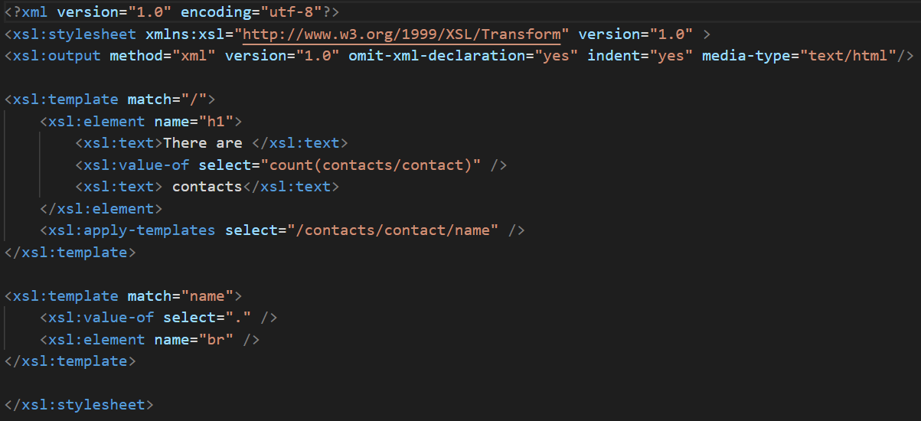
Step 5 commences the operation by (in a PHP environment) using the command transformtoXML. This uses XPath to find the desired data then uses the rules defined in the XSL file to transform the xml data into a displayable form. And step 6 is just reading out the newly transformed data. in all the code would look like this.
$url = "http:// highwaysengland.co.uk/travel-updates/traffic-information-
rss-feeds?p=Newcastle /rss.xml" ;
$xml = new DOMDocument() ;
$xml->load($url) ;
$xsl = new DOMDocument() ;
$xsl->load("../model/rss.xsl") ;
$proc = new XSLTProcessor() ;
$proc -> importStyleSheet($xsl) ;
$result = $proc -> transformtoXML($xml) ;
echo '<div class="row">' ;
echo $result ;
echo '<div class="row">' ;
by using this method, the PHP coding is simple all the work is handled by the XSL file.
3c) Method 1 and 2 are both viable for displaying XML there are a several key differences where developers are concerned. These ate, that the PHP method is the standard programming standard of order of execution. E.g get this do that then that. XSLT is a set of rules that a system follows when reading through a XML file. XSLT is focused on what happens not how it happens. This confuses most programmers since they are always concerned with the how. Another big difference is that XSLT is not language dependent and can be used in any other language. Whereas if a change I needed in the PHP example the programmer would have to rewrite the entire function to read the xml into the new desired format. This would mean the website would have to be takedown will the frontend is updated. With XSLT however the only change needed would be to update the XSL file meaning the whole site can stay up and the change can be implemented quickly. Lastly the specification needed in the PHP method requires the user to loop through the xml document and specify what they require. With XSLT the hard work is handled by the in-built Engine all the programmer must do is specify what the final output should look like. The engine will find and transform the data in to the required language and format.

4a) In order to ensure that only the admin can update the database used by the website. I would use different levels of protection. First would be to use a standard password verification system and add a check for the level of admin clearance. Second would be to make the link to the admin page invisible to other users. For the password validation system I would use the standard PHP password_verifiy to check the admins entered data and the date stored in the user database found using the admins username. I am assuming that this system enforces unique usernames. I would also add a column to the database that acts as a check, that if positive marks the user as an admin. So when I query the database for the admin data I would add to the query to get this admin check. Then I would add to the login function an if statement that checks if the admin check is positive or negative. If the check is negative the user continues as normal. However, if positive the system creates a session variable that signifies the user as an admin. For the second part I would add a check to all the main pages that check if the newly made variable exists. If so the link to the admin pages would be set as interactable. If not the link will be hidden form the page. As an extra precaution I would add to the admin pages a check for the session variable if it is not it will redirect to the websites main pages. The checks would look something like this:
session_start();
if ($_SESSION['uid'] != 'Admin') {
header('Location: index.php');
}
if (isset($_SESSION['uid'])) {
echo'<a href="admin.php" class="btn btn-primary">Admin</a>';
}

4b) In theory when adding a new item to the websites database would require the use of all three sections of the MVC frame work. The method starts on the admin page (view) this could contain a list of all items currently stored in the database. It must however contain a form where the admin must enter the new item’s details (fig 1). Upon submitting this form, the data will be sent to the corresponding file in the controller file in this case createItem. Here the inputted data is formatted into an PHP object (fig 2). Next a Curl call is prepared using JSON RPC the wanted method, parameters, a unique ID and the RPC version. All this is made into a PHP object which is sent using curl. First however, the request is JSON Encoded using the command json_encode (fig 3). The request is sent (fig 4) using the Post http verb now this file waits for a response. The request will be sent to the main page of the Model section where the request is decoded using json_decode(fig 5). It is checked for JSON formatting and for a valid request. From there if all tests are valid, the method parameter is checked using a switch statement. Once the right method is found in this case createItem (fig6) using the included API (also stored in the model folder) functions of the same name is called using the admin entered data JSON encoded for easy data transfer. Within this function a prepared statement for adding a new row into the database is ready. The prepared statement is filed in using the JSON decoded admin entered data which is then set to the database through a connection file stored on the model folder (fig 7). Once the statement is executed the result is sent all the way back to the Main model page where a response is made and sent back to the controller page where the result is displayed to the admin (fig 8). If the request was successful the PHP functions on the Main Page should automatically display the new item.
Fig 1 fig 2
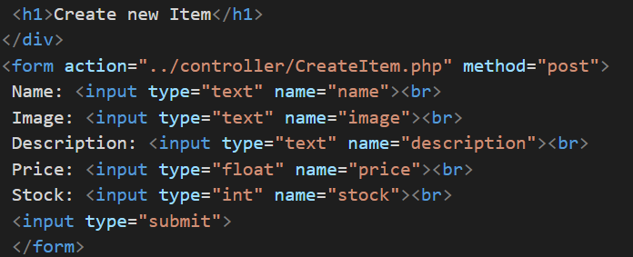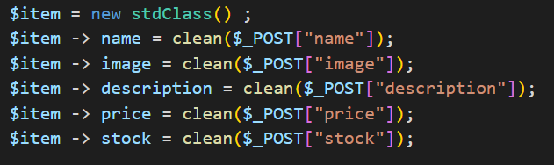

Fig 3 fig 4
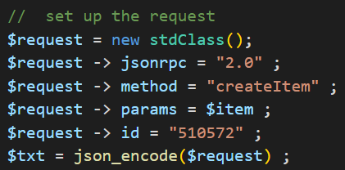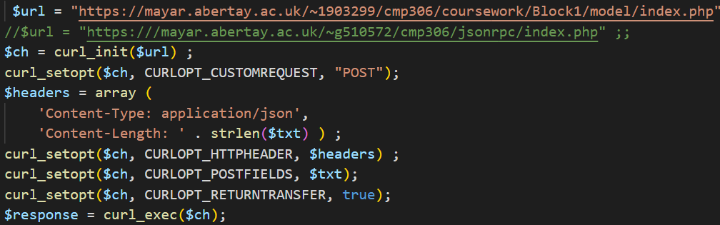
Fig 5 fig 6
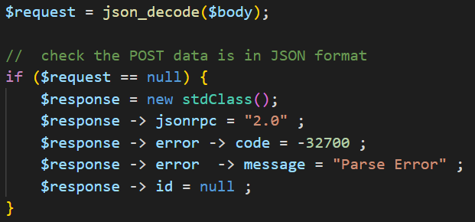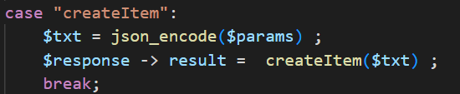
Fig 7 fig 8
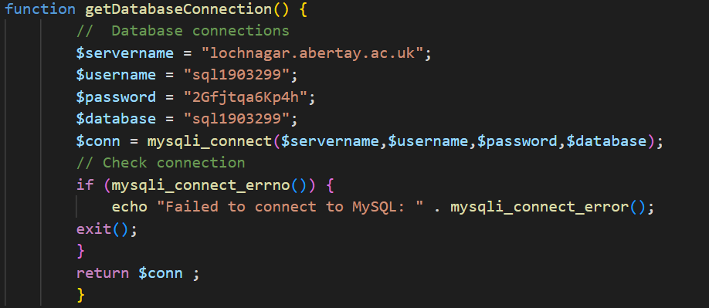

4c) In order to not display the image using an URL the programmer would have to store the images on the web server. It would then just be the case of saving the name of the image instead of the link itself e.g., image12.png. Then all the programmer would have to do is format the outputted data as a file source instead of a URL source fig 1. This would require adding the image name variable into the string as seen on line 11 of fig2.
Fig 1
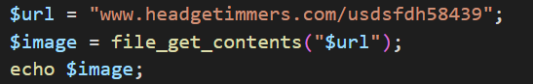
Fig 2


